INTERNSHIP ON WEB-BASED E-COMMERCE APPLICATION DEVELOPMENT AT REM ECO SAVERS LTD. USING REACT JS

ANANNA ISLAM BEDUSHE



INTERNSHIP ON WEB-BASED APPLICATION DEVELOPMENT AT REM ECO SAVERS LTD. USING REACT JS

ANANNA ISLAM BEDUSHE

An internship report submitted

in partial fulfillment of the requirements

for the degree of

Bachelor of Science in Computer Science and Engineering

UNIVERSITY OF LIBERAL ARTS BANGLADESH

Dhaka, Bangladesh

May 5, 2020

DECLARATION

I declare that this internship’s project entitled “*Internship on Web-Based Ecommerce Application Development at REM Eco Savers Ltd. Using React JS*” is the result of my research except as cited in the references. The internship report has not been accepted for any degree and is not concurrently submitted in the candidature of any other degree.

Signature :

**Name :** ANANNA ISLAM BEDUSHE

**ID :** 143014003

**Date**  **:** May 5, 2020

CERTIFICATE OF APPROVAL

The internship’s project report entitled “*Internship on Web-Based Application Development at REM Eco Savers Ltd. Using React JS*” is submitted to the Department of Computer Science and Engineering at the University of Liberal Arts Bangladesh (ULAB) in partial fulfillment of the requirements for the degree of Bachelor of Science**.**

Dated: May 5, 2020

|  |  |
| --- | --- |
|  | |
| **Professor Dr. Md. Abdul Mottalib**  Head of Department  Computer Science and Engineering  And Dean of School of Science and Engineering  University of Liberal Arts Bangladesh | Signature & Date |
| **Dr. Muhammad Abul Hasan**  Assistant Professor  Computer Science and Engineering  University of Liberal Arts Bangladesh | Signature & Date |

DEDICATION

To my lovely parents and my siblings who gave me endless love, trust, constant encouragement over the years, and for their prayers.

To my mentors and peers for their patience, support, love, and enduring the ups and downs during the completion of this report.

This report is dedicated to them.

ACKNOWLEDGMENT

I wish to express my most significant thankfulness to every last one of the people who helped me, some way or another, to complete this project. From the outset, I offer thanks to Almighty Allah who gave me the strength, direction, purpose, and patience all through the project.

I would like to thank our department head, Prof. Dr. Md. Abdul Mottalib and my supervisor Dr. Muhammad Abul Hasan for approving my report. And I am thankful to my project supervisor Dr. Muhammad Abul Hasan sir all his patience, guidance, direction, and support during the execution of this project. Through his expert guidance, I was able to overcome all the obstacles that I encountered in these enduring three months of my project. He always gave me immense hope and direction every time I consulted with him over problems relating to my project.

Finally, I am thankful to my friends and family for their unconditional love and support.

ABSTRACT

This report is the reflection and also the journey of my three months internship period along with the highlights of what I learned through errors, work responsibilities, and the importance of internship program at REM Eco Savers Ltd.. The knowledge I have gained as a new developer on web application development, new frameworks, and also how to work in an office environment is splendid. As an intern, my work was to learn and focus on web application projects. In this report, I have focused my work territory and explain my achievements which I have got through my internship at REM Eco Savers Ltd..

TABLE OF CONTENTS

**CHAPTER TITLE PAGE**

DECLARATION ii

CERTIFICATE OF APPROVAL iii

DEDICATION iv

ACKNOWLEDGMENT v

ABSTRACT vi

TABLE OF CONTENTS vii

LIST OF TABLES xi

LIST OF FIGURES xii

LIST OF ABBREVIATIONS xiii

|  |  |  |
| --- | --- | --- |
| **1** | **INTRODUCTION 1** | |
|  | 1.1 Objectives | 2 |
|  | 1.2 Scope of the Report | 2 |
|  | 1.3 Methodology | 3 |
|  | 1.4 Limitation | 4 |
|  | 1.5 Arrangement of The Report | 4 |
|  |  |  |
| **2** | **COMPANY PROFILE** | **5** |
|  | 2.1 Services | 6 |
|  | 2.2 Departments | 7 |
|  | 2.3 Roles and Responsibilities | 7 |
|  | 2.4 Working Environment | 8 |
|  |  |  |
| **3** | **TOOLS AND TECHNOLOGIES** | **9** |
|  | 3.1 Overview | 9 |
|  | 3.2 Why React JS | 9 |
|  | 3.3 Comparison | 10 |
|  | 3.4 Node Modules | 11 |
|  | 3.5 The Language used for Web Development | 12 |
|  | 3.6 Editor: Visual Studio Code | 12 |
|  |  |  |
| **4** | **DEVELOPMENT PROCESS** | **13** |
|  | 4.1 Project Design | 13 |
|  | 4.1.1 USE-CASE Diagram | 14 |
|  | 4.1.2 CLASS Diagram | 15 |
|  | 4.2 Project Functionalities | 15 |
|  | 4.3 Implementation | 16 |
|  | 4.4 Database Structure | 24 |
|  | 4.5 Project Analysis | 25 |
|  |  |  |
| **5** | **CONCLUSION** | **28** |
|  | 5.1 Conclusion | 28 |
|  | 5.2 Scope of Further Development | 29 |
|  |  |  |
|  | **Reference** | **30** |
|  |  |  |

LIST OF TABLES

|  |  |  |
| --- | --- | --- |
| **NO.** | **TITLE** | **PAGE** |
| 2.1 | Overview of company profile | 5 |
| 2.2 | Tools and Languages List used by me for the development of a different type of products at REM Eco Savers Ltd. | 7 |
| 2.3 | List of Database Management System at REM Eco Savers Ltd. I used for the development of my product | 7 |
|  |  |  |
|  |  |  |
|  |  |  |
|  |  |  |

LIST OF FIGURES

|  |  |  |
| --- | --- | --- |
| **NO.** | **TITLE** | **PAGE** |
| 3.1 | Google Trends comparison result in USA | 10 |
| 4.1 | Use Case diagram | 14 |
| 4.2 | Class diagram | 15 |
| 4.3 | Home page | 16 |
| 4.4 | Header of the project | 17 |
| 4.5 | Body of the project | 17 |
| 4.6 | JSON data | 18 |
| 4.7 | Code for API get request | 19 |
| 4.8 | Footer part of the project | 19 |
| 4.9 | Footer portion of the project | 20 |
| 4.10 | Product details page | 21 |
| 4.11 | Cart page of the project | 21 |
| 4.12 | Cart page of the project | 22 |
| 4.13 | User registration page of the project | 22 |
| 4.14 | User login page of the project | 23 |
| 4.15 | Database Structure | 24 |
| 4.16 | User Table Database Structure | 24 |
| 4.17 | Cart Table Database Structure | 25 |
| 4.18 | Home page of pvcrfidcardprintingsolution.com | 26 |
| 4.19 | Product details page of pvcrfidcardprintingsolution.com | 27 |

LIST OF ABBREVIATIONS

CSE Computer Science and Engineering

ULAB University of Liberal Arts Bangladesh

PHP Personal Home Page

HTML Hypertext Markup Language

CSS Cascading Style Sheets

JS JavaScript

API Application programming interface

# 

###### INTRODUCTION

An e-commerce web application is an online portal that is used to sell, buy, and exchange goods and services over the Internet and is also known as an electronic business system. Day by day it is gaining lots of popularity and so that reason I give concern towards the e-commerce platform and develop a site that will be beneficial for the users.

I give priority to the main concept of e-commerce platform which is business in a web app and there are four types of e-commerce web platform e.g. business-to-business (B2B), consumer-to-consumer (C2C), business-to-consumer (B2C) and consumer-to-business (C2B). Our project focuses on the business to consumer (B2C) type and which has a remarkable capacity for businessmen and consumers.

I joined the REM Eco Savers Ltd. which is a popular private software company in Bangladesh for IT services as an intern web developer. I was suggested to learn their work process and how to maintain their standards so that I can understand how they work together and how they manage the framework to complete their project. After that, I found the opportunity to work with their web application development team. In the time of my internship, I have gained practical knowledge on web development, new frameworks, and also gained how to maintain a web application, different programming languages, learn about security and office etiquette, and mostly how a software firm works for the satisfaction of clients. Also, I have learned the most popular JavaScript library, React JS, and Node JS using the coding technique and design skills I have learned in my courses at my university. After that I have successfully finished my task in due time and which gives the previous e-commerce project a more effective look and makes it more user friendly.

In this report, I have described all my working processes and the achievement area which I received from REM Eco Savers Ltd..

## Objectives

Behind the report, there are general objectives and specific objectives to fulfill which are demonstrated below:

**General Objective:**

This internship report is created for completing the Bachelor’s degree requirements in computer science engineering program under the Faculty of Computer Science and Engineering (CSE), University of Liberal Arts Bangladesh.

**Specific Objective:**

1. To give an outline of REM Eco Savers Ltd. including its products, mission, services, work environment, vision, and facilities.
2. Learn and get knowledge about their working style with the client and proper utilization.
3. The initial target to learn how to manage, coordinate, and communicate teamwork and make a profitable product.
4. Develop my skill, as a developer, implementation and maintenance of web app, and time management as an intern.

## Scope of the report

The Department of Computer Science and Engineering (CSE) at the University of Liberal Arts Bangladesh (ULAB) has an internship program to complete their Bachelor of Science program, for fulfilling the requirements this report is prepared for. The goal of this internship is to teach a student how the real job market works and acquire practical knowledge of how to handle the office & clients. Moreover, the biggest challenge for an intern is to convert the theoretical knowledge in practical life working experience. Also, this report is concentrated on analytical enhancement and web application development progress.

## Methodology

For completing this report, data has been acquired from both primary and secondary sources.

**Primary Sources:**

The important information has been gathered by face to face interviewing authorities, and by asking employees by working side by side and deskwork. To extend, acquired data is being used to complete the report.

I communicated with the company experts for information are:

        i.            Md Shohel Rana, CEO.

      ii.            Tanvir Hossain.

    iii.            Pijush Kanti.

Moreover, a few of the information I have been acquired by commonsense that I have to experience as an internee.

**Secondary Sources:**

My office provided me with a few information in the form of files and documents. I also take some significant help form web resources, researches, and articles that motivate me to finish my report and those links have been given in the references.

## Limitation

This report is made with the given information that I have collected from the employees of REM Eco Savers Ltd.. I have confronted such a huge number of challenges. Some data that I need from the company has not been given to me for their privacy policy and some of my colleagues think that the data I need from them is confidential and they would prefer not to disclose it in public. I couldn't add some information to my report for the company security reasons. Another issue was as far as possible is the time limit. Since we have just an exceptionally brief timeframe, it is extremely hard for me to investigate and analyze everything and make the report extremely clear, however in this brief timeframe I have attempted my best to finish the report.

## Arrangement of the report

In chapter one, I have described the introduction, main objective, scope of the report, and the methodology. After that, I give concern to chapter two and in this chapter, I mainly describe my company profiles. I give a full description of the service, department, working environment, and responsibilities of the company. Then, I give concern about the tools and technologies part of the project and I represent all technical details in chapter 3. In chapter 4, I give full attention to the project development process and its attributes. Finally, in chapter 5, I explain and conclude part of my internship report.

**COMPANY PROFILE**

In this section, we mainly focus on the internship company profile and describe briefly about that company. In section 2.1, we will describe the service of REM Eco Savers Ltd.. After that, we will give short notes about the departments and roles and responsibilities of that company in section 2.2 and section 2.3 respectively.

REM Eco Savers Ltd. is one of the growing IT Services companies in Bangladesh with a team of more than 50 people. We are celebrated for our unpredictable organization culture. Our experience and huge arrangement permit us to convey services on an unmatched scale. We have built leading brands within the digital space and are the go-to-agency for IT Training & Application testing services. REM Eco Savers Ltd. believes in customer satisfaction and its mission to build up a strong relationship with customers & partners. Information on Company given in below.

Table 2.1: Overview of company profile.

|  |  |
| --- | --- |
| **Company Name** | **REM Eco Savers Ltd.** |
| **Address** | 104, Capital Market, Shop No 43,  (2nd Floor) Farmgate, Dhaka-1205 |
| **Contact Number** | 01912013170 |
| **Year of Establishment** | 2012 |
| **Email** | Mdshohel_rana@yahoo.com |
| **Company Website** | [www.banglasoftcomputer.com](http://www.banglasoftcomputer.com)/v1 |

## Services

Our mission is to understand the customer’s requirements & resolve their technology troubles in due time. We provide devoted flexibility to custom-built solutions & dedicated to staying vanguard with reliable & proven technology to:

1. Client satisfaction and giving them the most pioneering services.
2. Thrive as a creative and inspire the workforce.
3. Building up a strong, friendly, and compassionate relationship with clients and business partners.

**The vision of REM Eco Savers Ltd.**

To understand the vision of REM Eco Savers Ltd. will:

1. Fulfill the demands of society and works positively towards the interests of humanity
2. Attain a state of profitability in the entirety of its tasks through the powerful and proficient utilization of assets, selection of suitable innovation, and arrangement with the center skills.
3. Develop its workers by enabling fortifying and compensating headway.
4. Encourage and aid the subjective enhancement of the administrations of its providers and merchants.
5. Providing the best and administrations of high and reliable quality, guaranteeing an incentive to its customers. [1], [2].

## Departments

### Development Tools and Languages of REM Eco Savers Ltd.

Table 2.2: Tools and Languages List used by me for the development of the different types of products at REM Eco Savers Ltd..

|  |  |
| --- | --- |
| **No.** | **Web Technologies** |
| **01** | React (Framework for Web and App Development) |
| **02** | JavaScript (Programming Language for the Web) |
| **03** | HTML5 (Programming Language for the Web) |
| **04** | NodeJS (Runtime or server environment) |
| **05** | Android Studio (Software) |

**Database Management Systems**

Table 2.3: List of Database Management System at REM Eco Savers Ltd. I used for the development of my product.

|  |  |
| --- | --- |
| **No.** | **Database Systems** |
| **01** | MySQL |
| **02** | API URL call for JSON data |

## Roles and Responsibilities

We comprehend that each business is unique and their product needs are distinctive as well. Remembering that, we have manufactured administrations that can be custom fitted to meet every one of your necessities.

1. **Web Development**

REM Eco Savers Ltd. provides all facets of web application development including graphic design, custom websites, portals, intranets, and extranets.

1. **Website Maintenance**

REM Eco Savers Ltd. provides Website maintenance and support services.

1. **Web Hosting & Domain name**

REM Eco Savers Ltd. provides all kinds of Domain name services and web hosting.

1. **Software Development**

REM Eco Savers Ltd. software teams help our customers build customized software and the development of services for a wide variety of verticals and business domains.

## Working Environment

As an intern, I am blessed that I get the opportunity to explore an amazing work environment at REM Eco Savers Ltd.. All of my colleagues are cooperative, friendly, and understanding. I never felt left out because everyone is so inspiring and optimistic. My office has a place called the lobby we used to seat and talk about our ideas, vision, and our future goal.

###### tOOLS & TECHNOLOGIES

## Overview

Nowadays developers are comfortable with the framework for developing web applications, so why Laravel, Angular, Express, React, Django, and other MVC based frameworks are mostly used by web application developers around the world.

**1.1**    **Why React JS**

While researching with various web development technologies for developing my project I found that react is the most popular development platform that is used for building the reusable user interface (UI) component. With React a web application can be built which doesn’t need any reload for changing the data of the page which makes the application become faster & more scalable & it also makes the application user friendly.

Why I have selected react for my project there are some points are given below:

1. **Simplicity & fast learning curve:** React has a very simple & lightweight JavaScript library so any developer who is familiar with JavaScript can easily start with react. The learning materials are easily understandable and approachable.
2. **Reusable Components:** React has a component-based structure so we don’t need to write the same code for the smaller element into different web pages which is more efficient and time consuming for writing code.
3. **Fast Rendering:** React loads very quickly because React uses Virtual DOM to render the website. React with components to develop a website, and Virtual DOM simply replaces components instead of replacing all of the code for a website.
4. **Clean Abstraction:** React does not architectures like MVC, after all, it is only about the view level and you can design the architecture of your app according to your wishes [4], [5], [6].

## Comparison

React is a JavaScript library where Angular uses TypeScript and Laravel uses PHP. Every developer who is working with web & mobile application development is very familiar with JavaScript so React becomes the most popular & powerful application development platform.

While I am researching on the internet, I found that 86% of developers use React compared with Angular and Laravel which shows the large popularity of React around the world.

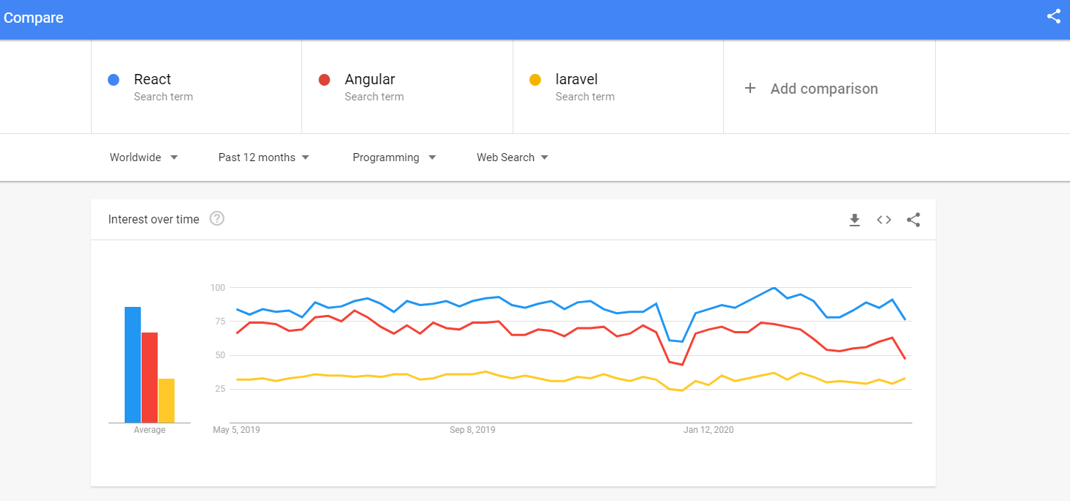

Figure 3.1: Google Trends comparison result in the USA

In React, many advantages stay along with their limitations. First of all, it will use a virtual DOM which is a JavaScript (JS) object and it will improve the performance of the apps since JavaScript (JS) virtual is faster than the regular DOM. To extend, it can be used on the client-side and server-side as well as another framework. Furthermore, component and data patterns improve readability which is helpful for the developer to maintain their large projects [5], [6].

## Node Modules

Node modules are the set of single or multiple JavaScript files that are used for giving functionality to any node.js application. React also uses this node module for giving functionality to any application. React already have some built-in node modules with it but I have used some extra modules for completing my project those are given below:

1. **React-router-dom:** This module is very important for this react project. It helps to route data or components from one to other pages. Its work is to call data from the page.
2. **Browser Router:** I used a browser router for this project, and this browser router uses regular URL paths. For tracking router history, it uses the HTML5 History API. My project server needed to be configured correctly for better performance. My web server requires me to serve the same page URLs that are used by the client-side React Router. [11], [15]
3. **React-bootstrap:** React-bootstrap module is used for installing the most popular CSS framework bootstrap which is helping to develop a responsive and mobile-friendly design.
4. **Link:** Links are really important for my project used in react-router-dom. It helps the user to navigate elements between several pages of React apps.
5. **Loadjs:** This is used in the project for finding or fixing any bugs.

## The language used for Web Development

I have used HTML5, CSS3, and JavaScript for the development of web applications.

## Editor: Visual Studio Code

Visual Studio Code (VS Code) is a source code editorial manager created by Microsoft that can be run on Windows, macOS, and Linux. It is free, open-source, and offers help for investigating just as implicit Git variant control, linguistic structure features, scraps, etc. The UI of the VS Code is exceptionally adjustable, as clients can change to various subjects, console alternate ways, and inclinations [3], [7], [8].

**DEVELOPMENT PROCESS**

## Project Design

A good project plan and design makes any project a lot easier. Project design is an initial stage of the project. When I joined REM Eco Savers Ltd. as an intern, my initial work was to rebuild an existing website by making it fast, dynamic, and responsive and it is tough. I worked day and night to accomplish this task by using React JS, a cutting-edge technology. In this section, we give full concern towards the use-case diagram of my internship project and that will be described in the portion of 4.1.1. After completing that, we will give focus on the class diagram and represent it in section 4.1.2. and Project functionalities in section 4.2, implementation in section 4.3. Database structure and Project Analysis in section 4.4 and 4.5.

## 4.1.1 USE-CASE Diagram

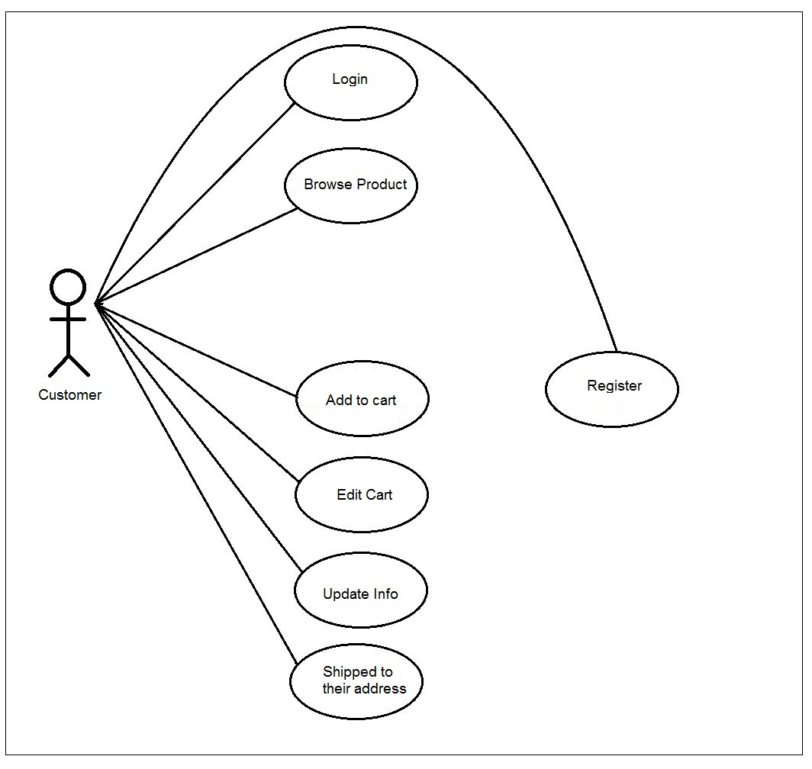

Figure 4.1: Use Case diagram

The Use Case Diagram given above shows a use case diagram is a graphic depiction of the interactions among the elements of a system. Use Case Diagram portrayed the system's functionality and necessity by using actors and use cases. It is represented by either circles or ellipses.

### Class diagram

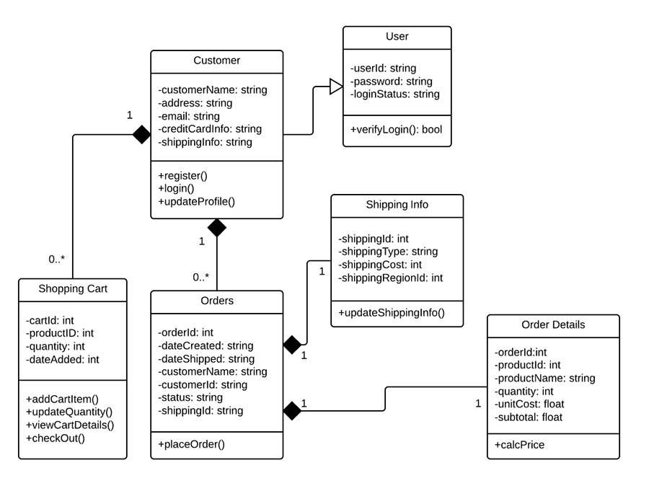

Figure 4.2: Class diagram

The class diagram is given above shows a class and the functions used in the project.

## Project functionalities

1. A user can register as a new member.
2. An existing user can log in.
3. A user can view all products.
4. A user can search for products by category.
5. A user can add any product to the cart.
6. A user can place an order for shipping to his address.

## Implementation

Figure 4.3 shows the home page of this project which is divide into three-part the header the body part and the footer part.

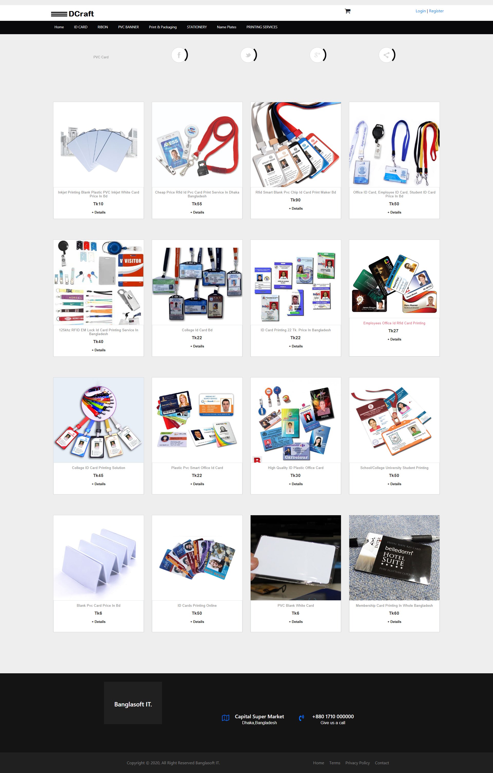

Figure 4.3: Home page

On the left side of the header (Figure 4.4) part contains the logo of the company and the right side has a login and registration button which takes the user to the registration and the login page. It also has a menu bar that contains the different product categories. After clicking any of them it will filter the products and give the user his desired result.

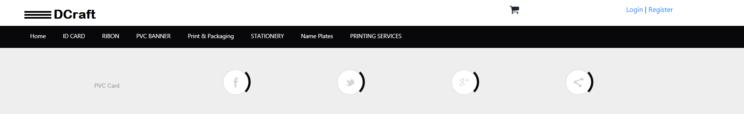

Figure 4.4: Header of the project

The body (Figure 4.5) contains the main part of the project which shows the list of all products to the user a user can easily find their expected product and if a user clicks on any product, he will get a detailed view of that particular product.

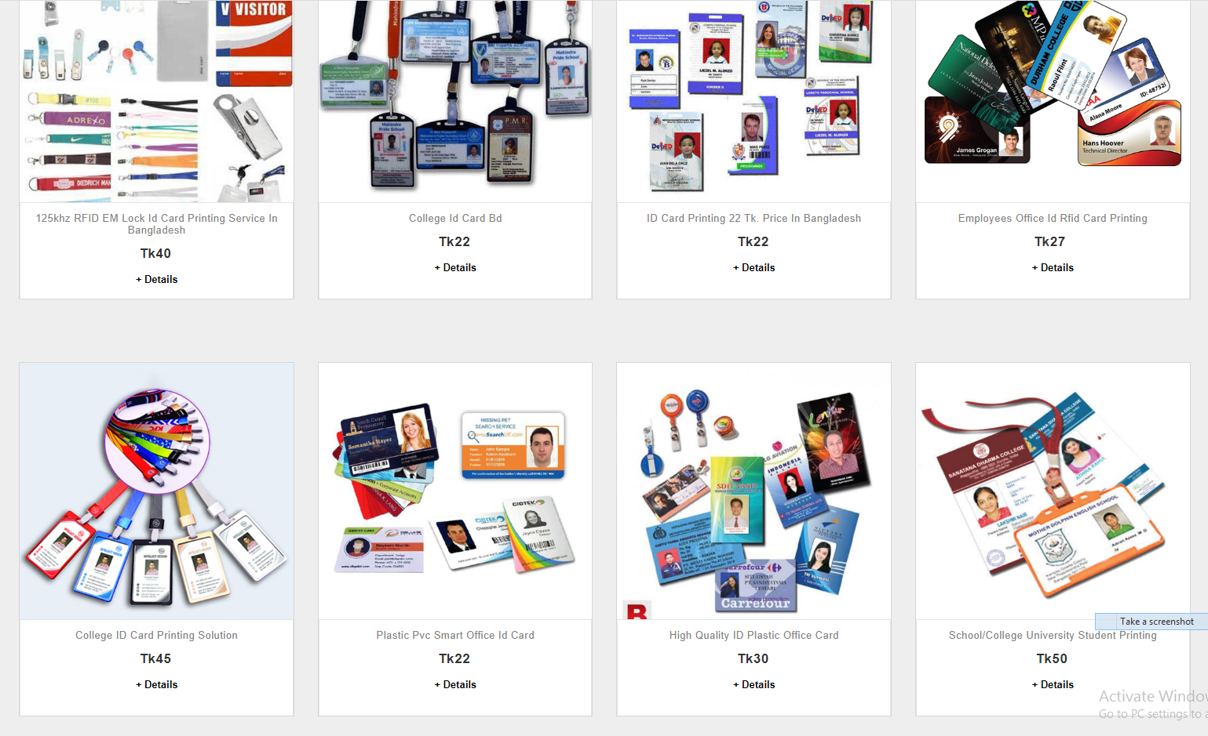

Figure 4.5: Body of the project

For importing this product list into our body part, I have used a restful JSON API. Figure 4.6 shows the data in which the API returns from the product database.

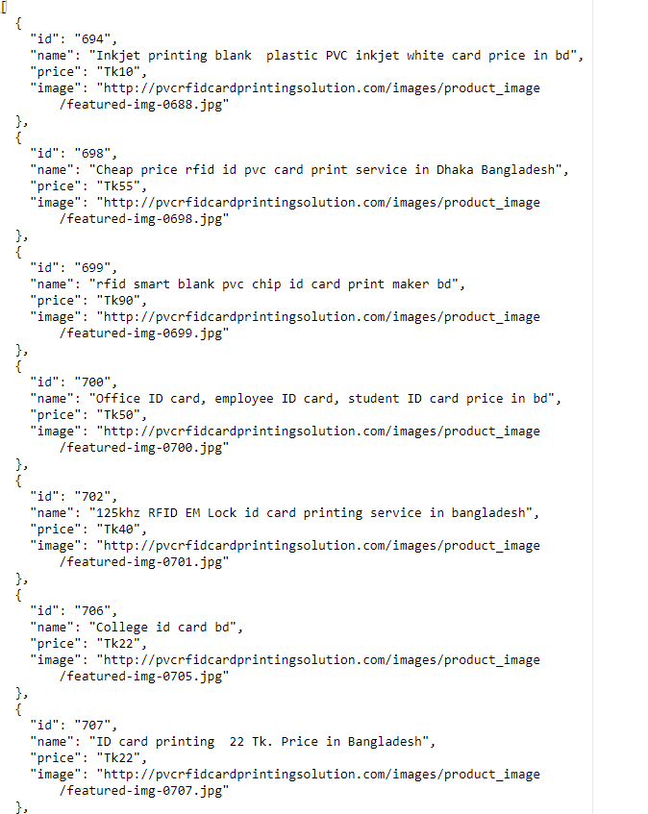

Figure 4.6: JSON data

For implementing this data into our body part, I have made a get request to that API URL figure 4.7 shows the code for the get request.

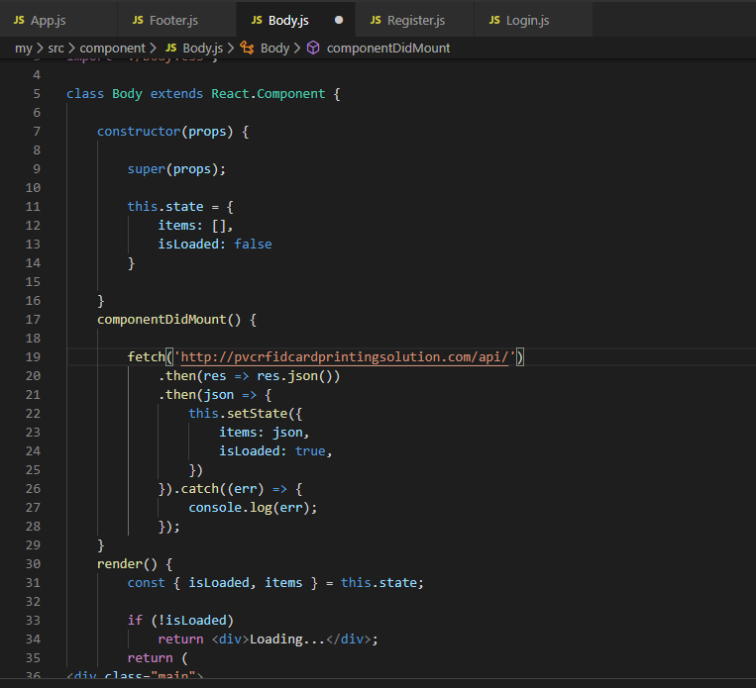

Figure 4.7: Code for API get request

The footer (Figure 4.8) part contains the contact details about the company it is the bottom part of any web page.

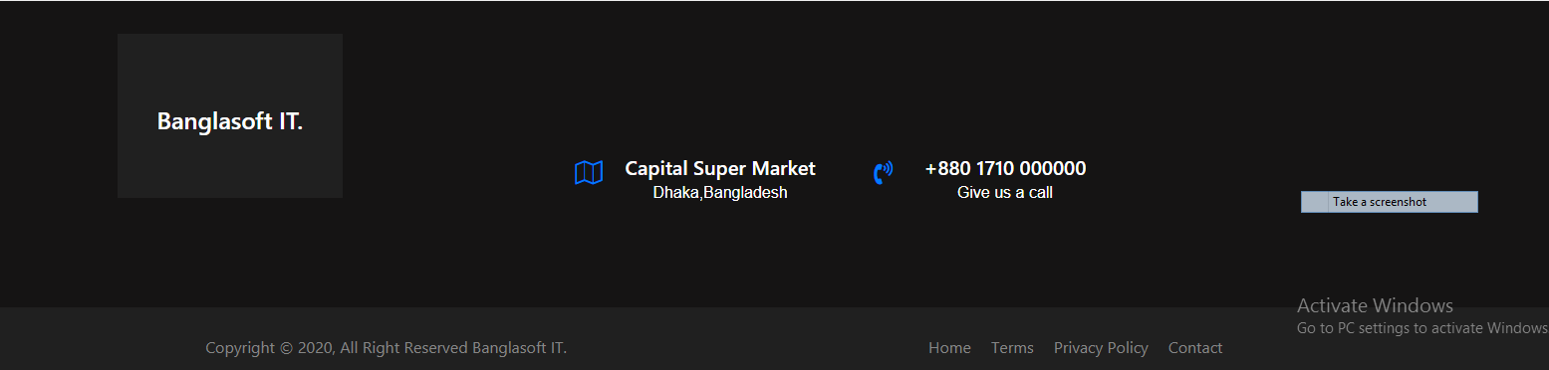

Figure 4.8: Footer part of the project

This is the complete code of the home page which contains all components of this project and where the react-router-dom module has used for routing data or components one to another.

import React from 'react';

import { BrowserRouter, Switch, Route } from 'react-router-dom';

import './App.css';

import Header from "../src/component/Header"

import Body from "../src/component/Body"

import Footer from "../src/component/Footer"

import Subproduct from "../src/component/Subproduct"

import Details from "../src/component/Details"

import Login from "../src/component/Login"

import Register from "../src/component/Register"

import Cart from "../src/component/Cart"

import Checkout from "../src/component/Checkout"

function App() {

  return (

    <div className="App">

     <Header></Header>

     <BrowserRouter>

     <Switch>

     <Route path="/home" component={Body}></Route>

     <Route path="/register" component={Register}></Route>

     <Route path="/checkout:id?" component={Checkout}></Route>

     <Route path="/cart/:id?" component={Cart}></Route>

     <Route path="/login" component={Login}></Route>

     <Route path="/details/:id?" component={Details}></Route>

   <Route path="/category/:id?" component={Subproduct}></Route>

   <Route path="/category/details/:id?" component={Details}></Route>

      </Switch>

     </BrowserRouter>

<Footer></Footer>

    </div>

  );

}

export default App;

**Figure 4.9:** Footer portion of the project

This product details page (Figure 4.10) contains a brief description & other specification of that particular product which is selected by the user from the home page body section and then the user can also add the product on the shopping cart page by clicking the add to cart button.

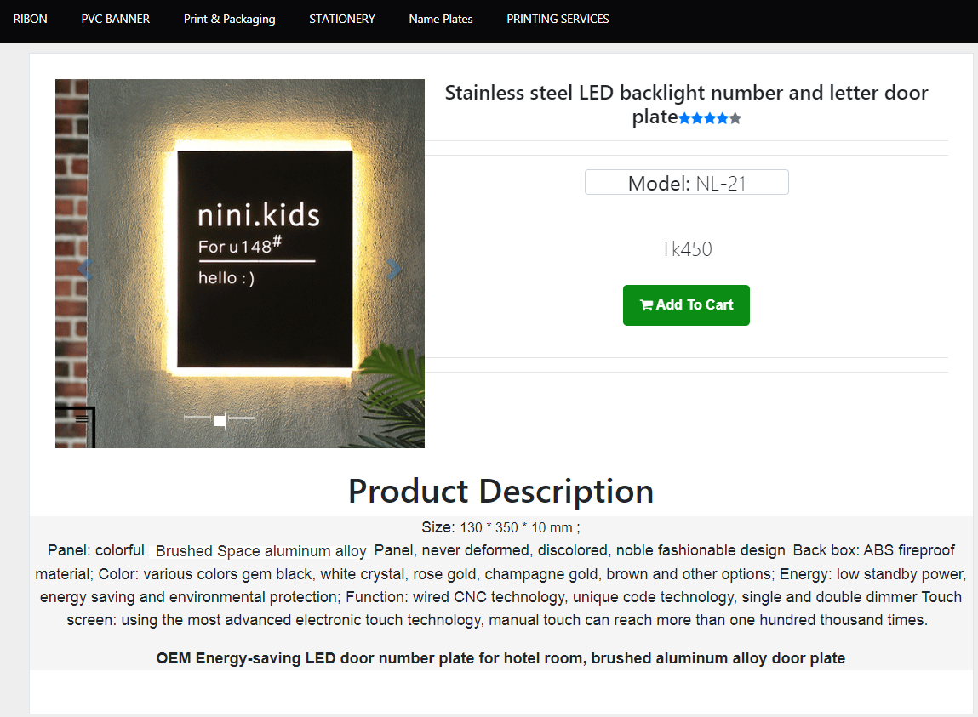

Figure 4.10: Product details page.

The cart page (Figure 4.11) shows the information about that product which is selected by the user for placing an order.

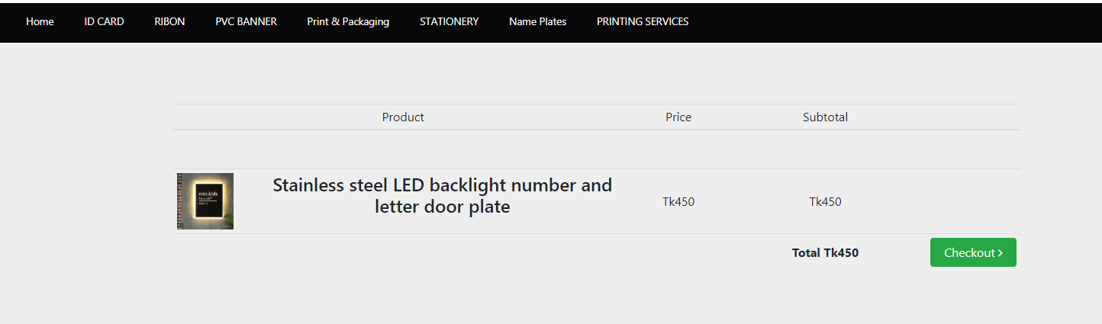

Figure 4.11: Cart page of the project.

The checkout page (Figure 4.12) is the final step of any e-commerce application in this stage users have to put their shipping details like his name address contact number and finally hit the place order button and his order will be successfully placed.

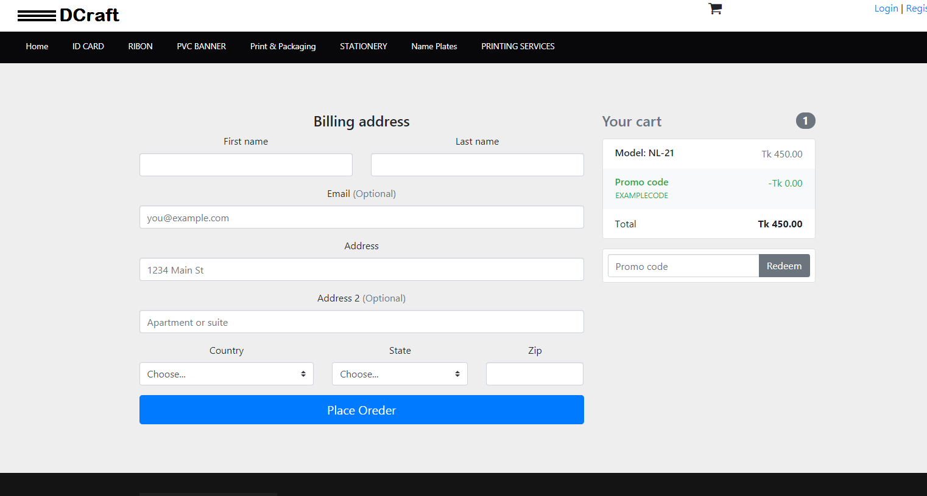

Figure 4.12: Cart page of the project.

This is the user registration page (Figure 4.13) of our project. If a user wants to become a member of the site, he just needs to fill out the form and hit the submit button after that he will become a registered member of this site.

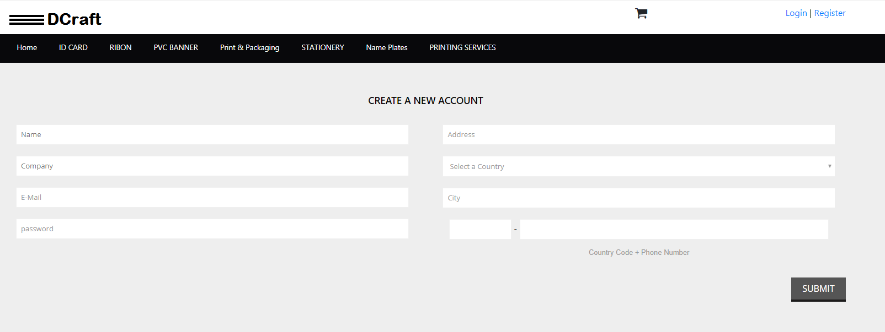

Figure 4.13: User registration page of the project.

A registered member can easily log in to this site for completing the checkout process by putting his login details into the user login form (Figure 4.14).

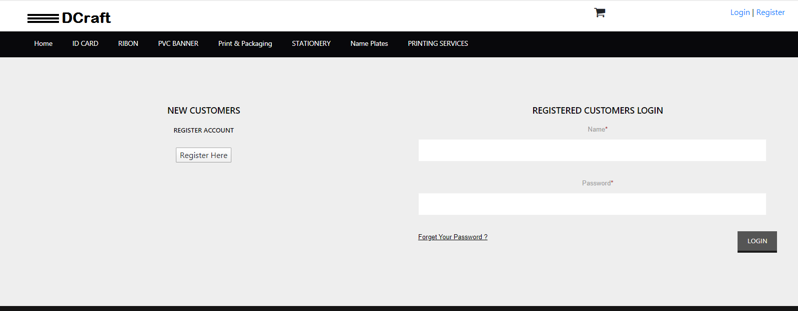

Figure 4.14: User login page of the project.

## Database Structure

Figure 4.15 shows the complete database structure of the project.

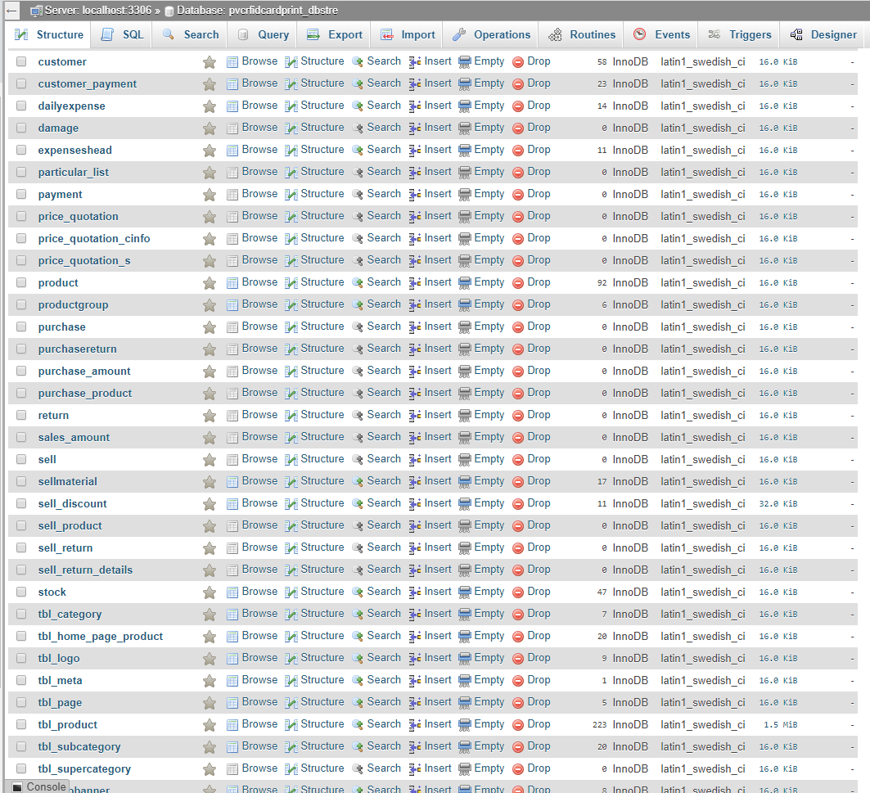

Figure 4.15: Database Structure.

Figure 4.16 shows the user table structure of the project.

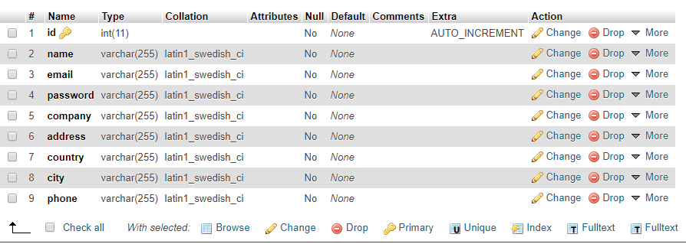

Figure 4.16: User Table Database Structure

Figure 4.17 shows the cart table structure of the project.

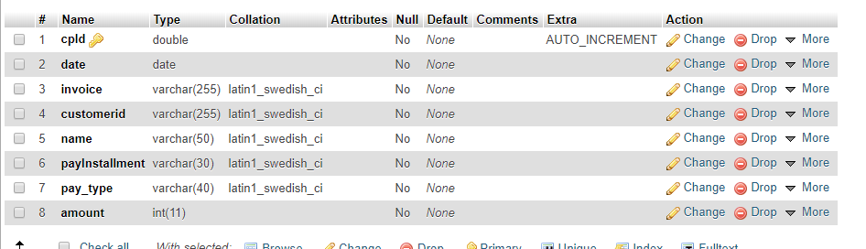

Figure 4.17: Cart Table Database Structure

## Project Analysis

I was offered for redeveloping and updating an eCommerce web application which is already developed by REM Eco Savers Ltd. during my intern period. They have established a lot of web applications in the market but for the security and privacy reason they can’t provide me any larger project but they gave me the complete source code of http://pvcrfidcardprintingsolution.com which was developed with basic PHP, Html, JavaScript, CSS & MySQL. My job was to convert the basic web application using React JS, and Node JS.

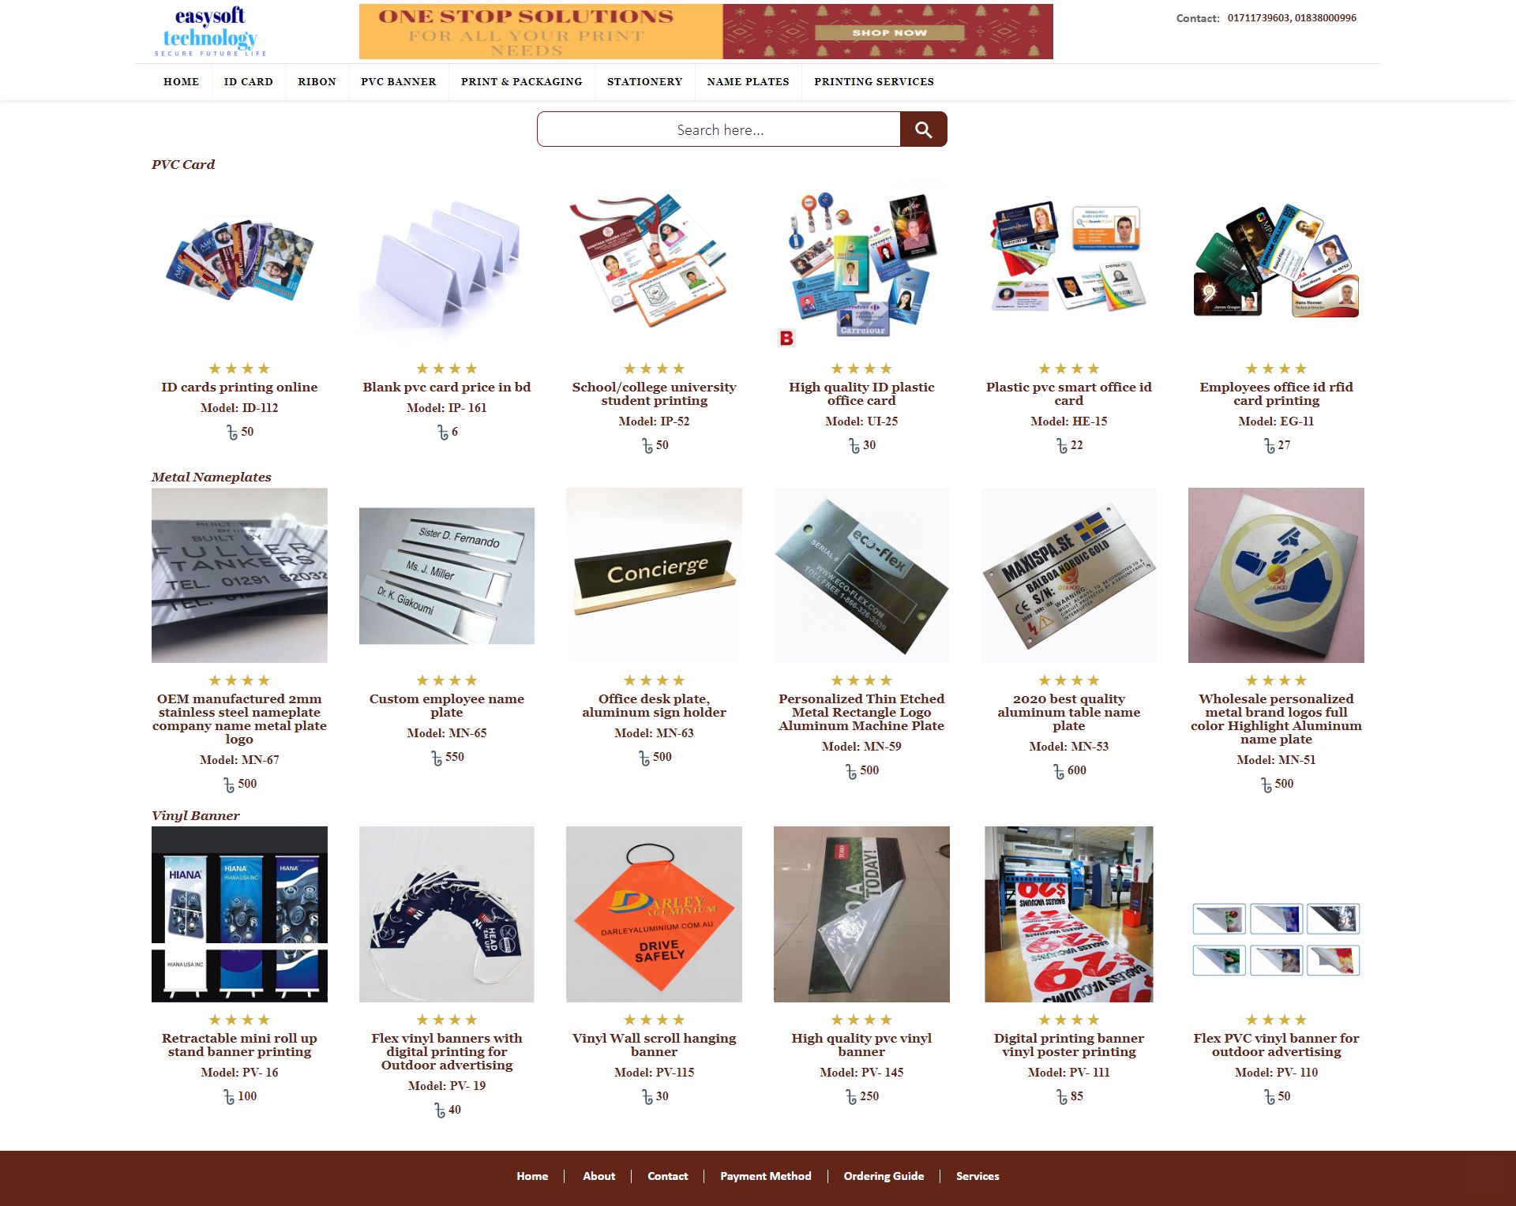

Figure 4.18: Home page of pvcrfidcardprintingsolution.com

Figure 4.18 is showing the home page of pvcrfidcardprintingsolution.com which was developed with basic PHP, Html, JavaScript & CSS, for this reason, the website was not completely responsive and it takes a lot of time for loading but during my development process I have implemented there bootstrap CSS framework that gives the home page an effective look and page become completely responsive and user friendly and for implementing React JS the website becomes faster than previous for loading. Figure 4.3 shows the current home page of the project.

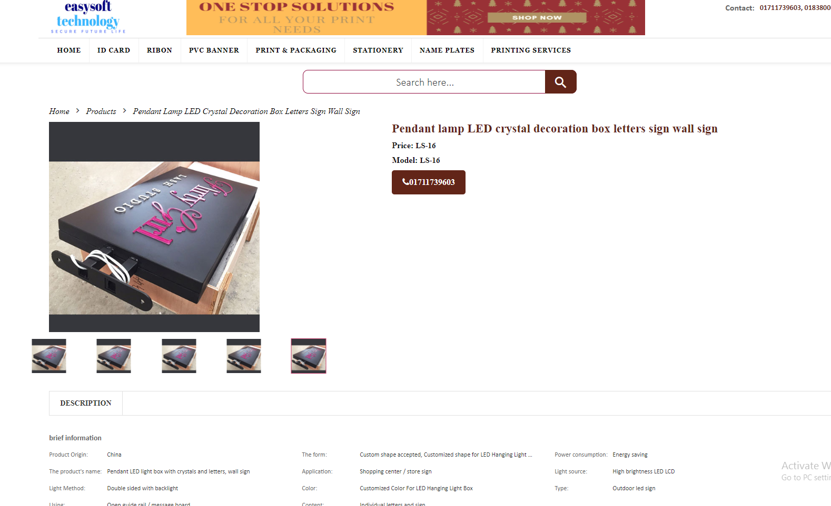

Figure 4.19: Product details page of pvcrfidcardprintingsolution.com

Infigure 4.19 we can see the product details page of pvcrfidcardprintingsolution.com I also design a newer version of product details page with bootstrap figure 4.9 shows that and there is no add to cart functionality button in pvcrfidcardprintingsolution product details page but I have added an add to cart functionality button which will store the current product information into the site cart page.

There was no cart page, checkout page, user logging, and registration page into pvcrfidcardprintingsolution previous project but I have added a cart page (Figure 4.11) a checkout page (Figure 4.12) a logging page (Figure 4.14) and a registration page (Figure 4.13) and their functionality into the project.

###### CONCLUSION

## Conclusion

Working with REM Eco Savers Ltd. as an intern has helped me to understand what is my area of ​​interest. I have gained an immense amount of technical knowledge from this work experience and I plan to continue it for my future career. I believe that my commitment as a web application developer won't solely enhance my career path however additionally I have to learn new technologies to improve my ability to create changes on my career path.

To extend, as an intern, I have learned React JS for web application development, and to code in a way that my code can be easily changeable, reusable, and easy to fix bugs and profitable and a new programmer can use it after. I used to React JS for my internship project development and while working with React JS, I found it easily learnable, usable, and there is a bright scope for me to choose to React development as a future path.

Also, I set myself some achievement list before the beginning of my internship for my improvement and I am pleased to inform that my achievement list was achieved precisely. On the other hand, I have learned to acclimate to work in a development team and also in a professional environment. As a web developer, I gain so much confidence dramatically due to my internship. I am ready to work in a professional organization and eager to contribute to growth and profit with all the skills I have acquired.

## Scope of Further Development

Web-based application development is a crucial topic for an e-commerce site. People can browse, choose the products, and order towards the company, and the company will be delivered the product within a few days. We have a plan to change and bring a few changes to this website. Besides, we have another plan to add a few functionalities in this website which are given below:

1. Add the chatting system.
2. Have a launch android app.
3. Add an online payment system.

###### Reference

[1] Visual Studio Code - Code Editing. Redefined, "Docs, Getting Started”. Available: https://code.visualstudio.com/. [Accessed: 18-April-2020].

[2] Scrum Alliance, "Scrum Role Demystified”. Available: https://www.scrumalliance.org/agile-resources/scrum-roles-demystified. [Accessed: 18-April-2020].

[3] Software Testing Materials, "Software Testing Definition, Types”. Available: https://www.softwaretestingmaterial.com/software-testing/. [Accessed: 18-April-2020].

[4] “SDLC”, [Online]. Available: [http://istqbexamcertification.com/what-are-the-software-development-life-cycle-sdlc-phases/. [Accessed](http://istqbexamcertification.com/what-are-the-software-development-life-cycle-sdlc-phases/.%20%5bAccessed): 18-April-2020].

[5] J. Duckeet, "Design and Build Websites," in *Design and Build Websites (1'st Edition)*, 2005.[Accessed: 18-April-2020].

[6] w3.org. [Online]. Available: <https://www.w3.org/standards/webdesign/htmlcss>. [Accessed: 18-April-2020].

[7] “Web-based applications”, [Online]. Available: [http://www.magicwebsolutions.co.uk/blog/the-benefits-of-web-based- applications.htm](http://www.magicwebsolutions.co.uk/blog/the-benefits-of-web-based-%20applications.htm). [Accessed: 18-April-2020].

[8] I. Sommervilla, in *Software Engineering,Ninth Edition*, PEARSON.

[Accessed: 18-April-2020].

[9] React Tutorial [Online], Available: <https://www.w3schools.com/REACT/default.asp> [Accessed: 18-April-2020].

[10] JavaScript Tutorial [Online], Available: <https://www.w3schools.com/js/default.asp> [Accessed: 18-April-2020].

[11] CSS Tutorial [Online], Available: <https://www.w3schools.com/css/default.asp> [Accessed: 18-April-2020].

[12] HTML Tutorial [Online], Available: <https://www.w3schools.com/html/default.asp> [Accessed: 18-April-2020].

[13] Primary Components [Online], Available:<https://reacttraining.com/react-router/web/guides/primary-components> [Accessed: 01-May-2020].